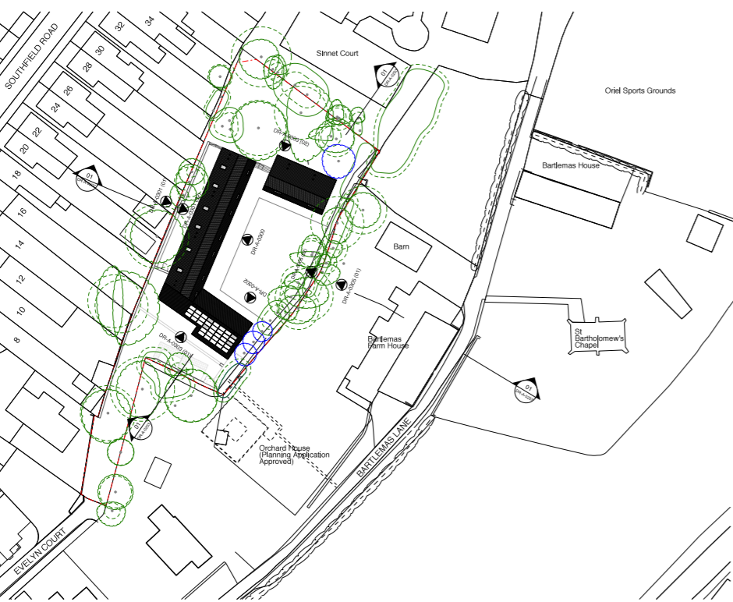
18/02989/FUL – Appendix 1 – Site Plan

